**Analytic Memo 6**

**Jessica Lewis, 10/15-10/19**

1. **What data did you collect this week?**

Tuesday 10/16

* Discussion #5 – The students read some more of their peer posts and added more peer comments. This was done to help promote discussion.
* I completed the **Teacher Observation Form** for each student.
* **Quiz #4**

Thursday 10/18

* Final Discussion #6 (Assessment) – gave students a challenging math problem regarding (+) and (-) integers in real life. They had to explain and justify their response.
* I completed the **Teacher Observation Form** for each student.
* I completed the **Blog Evaluation Form** for Discussion #6.

Friday 10/19

* **Post-Study Survey**

1. **Review the qualitative data that you collected this week. List five to ten words (potential codes) that come to mind as a result of this data.**

I did not add any new codes this week. These are the second-round codes I created from last week using the *focused coding* method from Saldana (2016)*.* This method organizes the most prominent codes from the first cycle of coding into 5 main categories. The main 5 categories represent the reoccurring themes that are displayed from the data. These will eventually be developed into the major findings of the study. Each main category has bulleted sub-categories outlining the details that helped to develop the main category or theme. Some of subcategory bulleted notes overlap because motivation, achievement, and self-efficacy are linked to each other. Below is what I came up with. Let me know if it makes sense.

This week I plan to take a final look at my codes and categories in preparation for the final two conclusive chapters of the paper.

Category 1: Increased motivation (engaged and focused) when:

* Using technology (Chromebooks)
  + “Digital natives” (familiarity)
* They understand the discussion question (discourse)
  + Strong literacy skills
  + Strong self-efficacy
* Collaborating with peers (audience)
  + Learning from each other
  + Support from friends
  + Presented with a challenge
* They value the discussion (intrinsic motivation)
  + Relates to learning
  + Discussion increases their understanding
  + Incorporates preferences and interests

Category 2: Decreased motivation (lack of effort) when:

* They do not understand the discussion prompt (discourse)
  + Prompt is too challenging
  + Low literacy skills
  + Low self-efficacy
* Asked to critically think (discourse)
  + Explaining thoughts
  + Justifying thoughts
  + Analyzing and conceptualizing peer posts
* Reading directions or long texts (discourse)
  + Low literacy skills
  + Critical thinking
* Reading peer posts
  + Seeking instant communication

Category 3: Peer audience increases self-efficacy (confidence in learning) by:

* Multiple perspectives
  + Access to new information
  + Increases understanding
* Clarification from peers
  + Supports confidence in knowledge/abilities
* Increasing awareness to details and writing quality
  + Conscious of spelling
  + Wanting to impress peers

Category 4: Mathematical discourse lays the foundation for blogging success:

* Become off task when they do not understand
* Lack of literacy skills impacts peer discussion
  + Poor writing impacts the readers understanding
  + Poor reading impacts understanding
* Strong literacy skills increase success on blog
  + Explaining & justification skills

Category 5: Peer discussion increases academic achievement

* In explanation skills
  + Displayed on blog posts and unit test
* Peer audience
  + Explain so peers can understand
* Still struggle with justification skills

1. **In a table, share the quantitative data that you collected this week. This data should not be individual according to student – but should be presented in the form of averages or percentages. Write a short explanation (one or two sentences) of what you think this data means in terms of your research question (s).**

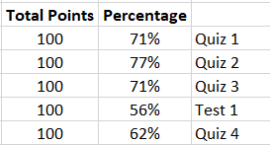**Quiz/Test Scores**

Although quiz/test results show a decline as the study went on, these assessments are designed by the district and do not directly correlate with the purpose of the blog.

**Teacher Observation Form -** The numbers below represent the average in each category for 9 students. The total amount of points for each category is 4.

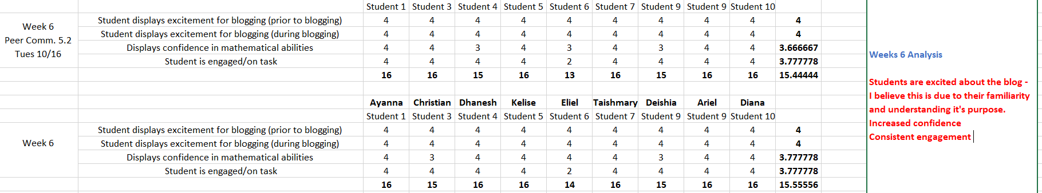

As the study progresses, the students become more and more exciting about the blog each week. They enjoy using the technology during math. Students understand how to access the blog and understand the purpose of writing on a blog. They are displaying more excitement before and during blog use and require less teacher direction each time we have a blog session. This is displayed in their confidence in mathematical abilities and engagement on the task. This instrument is strictly used for observations. Although a student may look confident in their mathematical abilities, this does not directly reflect their mathematical discourse and understanding of the content (this data is displayed in the **Blog Evaluation Rubric**).

**Blog Evaluation Rubric -** The numbers below represent the average in each category for 9 students. The total amount of points for each category is 2.

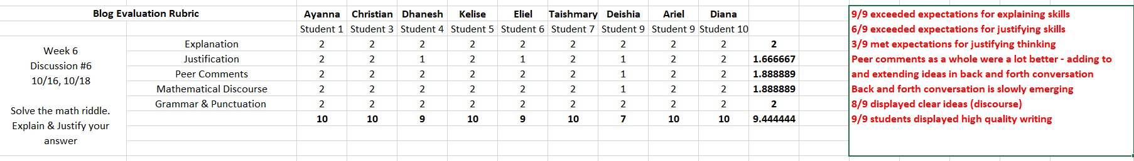

Again this week the blog evaluation rubric displayed a further increase in each category. Read the red comments for further detail.

**Post-Study Survey**

|  |  |  |  |  |  |
| --- | --- | --- | --- | --- | --- |
| *Pre-Study Survey* | Strongly Agree | Agree | Neither Agree or Disagree | Disagree | Strongly Disagree |
| **I enjoyed using the blog during math class** | 51% | 29% | 14% |  |  |
| **The blog helped me understand math better** | 29% | 43% | 29% |  |  |
| **The blog questions were easy for me to answer** | 29% | 43% | 29% |  |  |
| **I always tried to write high quality blog posts** | 29% | 43% | 14% | 14% |  |
| **I enjoyed receiving comments from my peers on the blog.** | 57% | 14% | 14% | 14% |  |
| **I liked writing comments to my peers on the blog.** | 43% | 43% |  | 14% |  |
| **The posts my peers wrote to me helped me learn** | 43% | 43% | 14% |  |  |
| **The blog was my favorite part of math class.** | 57% | 29% | 14% |  |  |
| **I would like to continue to use the blog in math.** | 57% | 14% | 29% |  |  |
| **The blog made it easier for me to explain my thinking in math** | 43% | 43% | 14% |  |  |
| **I feel more confident in my mathematic abilities** | 57% | 14% | 14% |  | 14% |
| **How did the blog help you learn?** | i dont know  it help me multiply decimals  if i didnt understand and i dont like asking teachers my pears can help  It helped me by people showing me what to do.  It helped me because there was questions and websites that were familyeir.  It helped me do questions i did not know how to do  by helping me understand how to do the thing i dont get in math  i dont know  it help me multiply decimals  if i didnt understand and i dont like asking teachers my pears can help  It helped me by people showing me what to do.  It helped me because there was questions and websites that were familyeir.  It helped me do questions i did not know how to do  by helping me understand how to do the thing i dont get in math  i dont know  it help me multiply decimals  if i didnt understand and i dont like asking teachers my pears can help  It helped me by people showing me what to do.  It helped me because there was questions and websites that were familyeir.  It helped me do questions i did not know how to do  by helping me understand how to do the thing i dont get in math  i dont know  it help me multiply decimals  if i didnt understand and i dont like asking teachers my pears can help  It helped me by people showing me what to do.  It helped me because there was questions and websites that were familyeir.  It helped me do questions i did not know how to do  by helping me understand how to do the thing i dont get in math | | | | |
| **What suggestions do you have to help improve the blog?** |  | | | | |

1. **Write at least one paragraph (it could be more if you like) reflecting on your experience of the week in terms of both student performance and your own practice.**

The students had another great week. Having completed the study, the data shows that the students have come a long way in improving their explanation and justification skills and their ability to engage in peer discussion. The students were sad to see the study end because they enjoyed interacting with their peers on the blog. By the end of the study the students understood the purpose of the blog and were able to tell me that it helped them learn to explain their thinking. One of my major learnings from the study was that the content needs to be relevant to the students interests and classroom learning for them to find value and purpose for participation on the blog. Students were much more excited when they understood the discussion post and became more motivated to use the blog when they saw how if benefited them. These 7th grade students also struggle to read and write. Over the course of the study, I supported their literacy skills by providing outlined steps and questions that guided their explanation and justification of their response. This helped them learn how to explain and justify their thinking.

1. **Write a few sentences (it could be more if you like) outlining the way that this week’s memo is different from last week’s memo.**

This week’s memo is different from last week’s memo because this is the conclusion of the study. I am can definitely find reemerging codes and categorize them into themes (see codes section of memo).

**Week 6 (Tues, 10/16) – Peer Comments #5.2**

* Students were directed to read more peer posts and expand on comments from before. This was done to promote peer discussion.
* One students asked “Can we continue the blog?”
* Students got right to work and were engaged and focused throughout the period.
* Not many questions from any of the students – knew exactly what to do.
* Next Time:
  + Discussion #6 – final discussion as a cumulative assessment to the entire blog study
  + Have them solve a problem that asked them to justify and explain their thinking

**Week 6 (Thurs, 10/18) – Discussion #6 (Final Assessment)**

* Students were directed answer the math riddle involving (+) and (-) integers in a real life situation. They had to explain and justify their answer in a comment.
* Students were sad that the blog study was ending.
* Students got right to work and were engaged and focused throughout the period.
* Not many questions from any of the students – knew exactly what to do.